Question 09
Looking into the following explain plan what should be your recommendation and implementation to improve the existing data model. Please share your solution in sql and the corresponding explain plan of that solution. Please take in consideration the way that user will use the app.

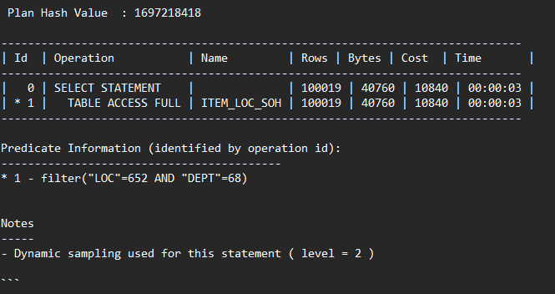
When analyzing the explain plan, it's clear that the query is performing a full table scan on the ITEM_LOC_SOH table, which is inefficient, especially when the table contains a large number of records. The query is filtering based on the LOC and DEPT columns, and the full table scan suggests that there is no index being used on these columns.
The first recommendation would be to create a composite index on the LOC and DEPT columns. This would allow the database to quickly locate the rows that match the filtering conditions without scanning the entire table. Indexing these columns would significantly improve query performance, especially for read-heavy operations where these columns are frequently used in the WHERE clause.
However, for very large datasets, there are additional considerations. As the table grows, partitioning the table based on a relevant key, such as LOC, could also be a beneficial strategy. By partitioning the table, the database would only need to scan the relevant partitions for queries filtering by that key, rather than the entire table. This would reduce the query time considerably when filtering by the partition key. Partitioning also provides easier data management as the dataset grows.
Both solutions (indexing and partitioning) can complement each other. Indexing ensures efficient access to the data for specific queries, while partitioning improves performance for larger datasets, especially as they scale. The choice between these two options depends on the size of the table and the frequency of queries filtering by partitioning keys. If the table is expected to grow significantly and queries often filter by LOC or other partitioning keys, partitioning should be considered. However, for smaller tables or when partitioning isn't necessary, creating an index would address the immediate query performance issue.

